Shell Shock Attack Task #1

After weeks of on and off I found an additional space in the function declaration(foo=’_()_echo “hello world”;_}; echo ‘extra’;’) stopped the bug. The textbook also seemed to have the space. Deleted it fixed my problems.

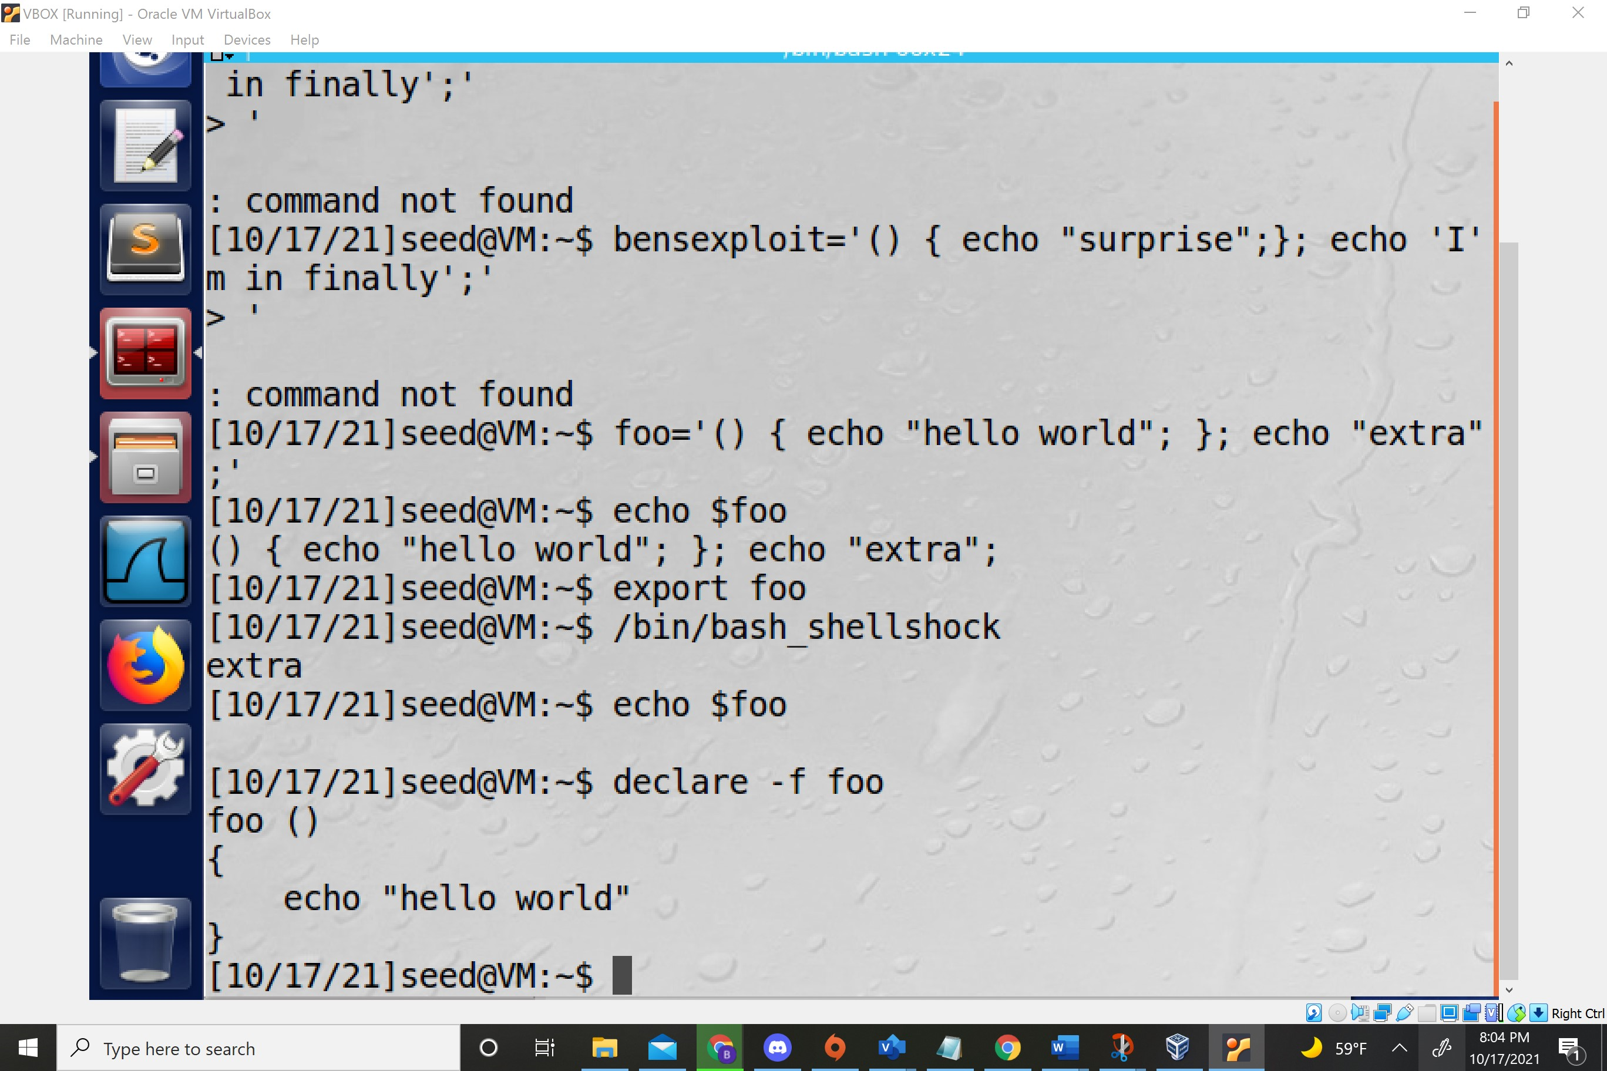

Shell Shock Assignment Task #2

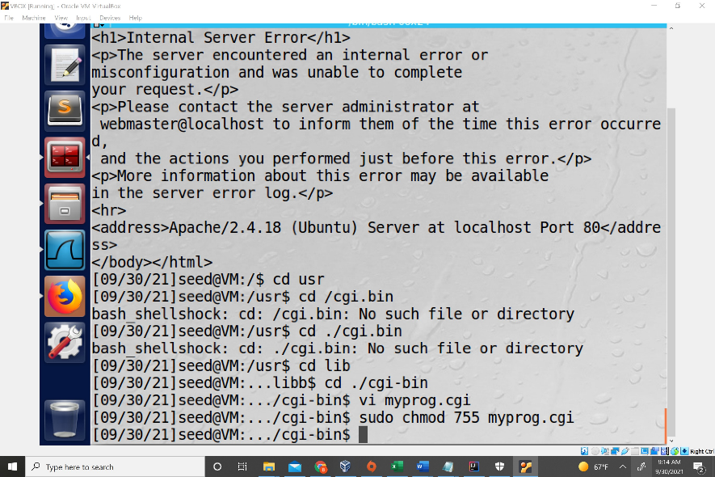

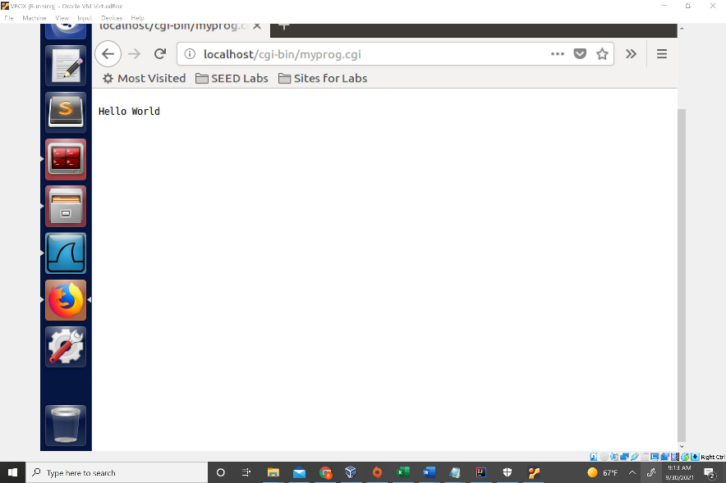

Shell Shock Assignment Task#3

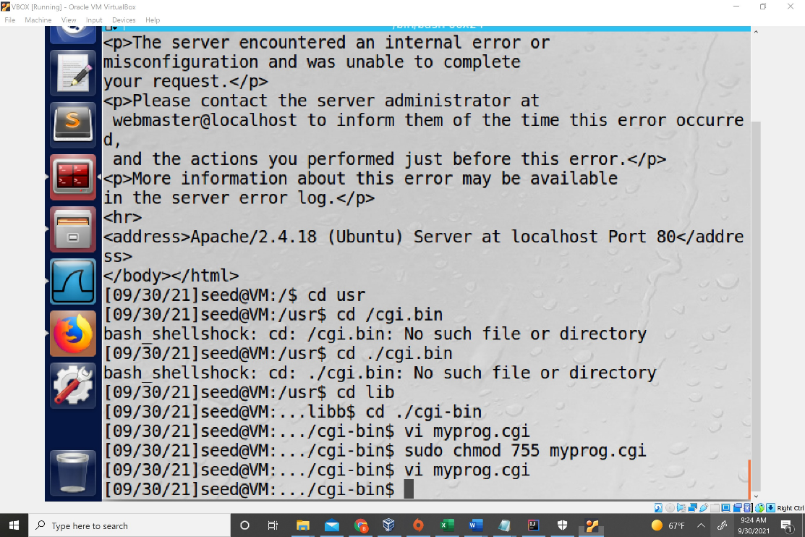

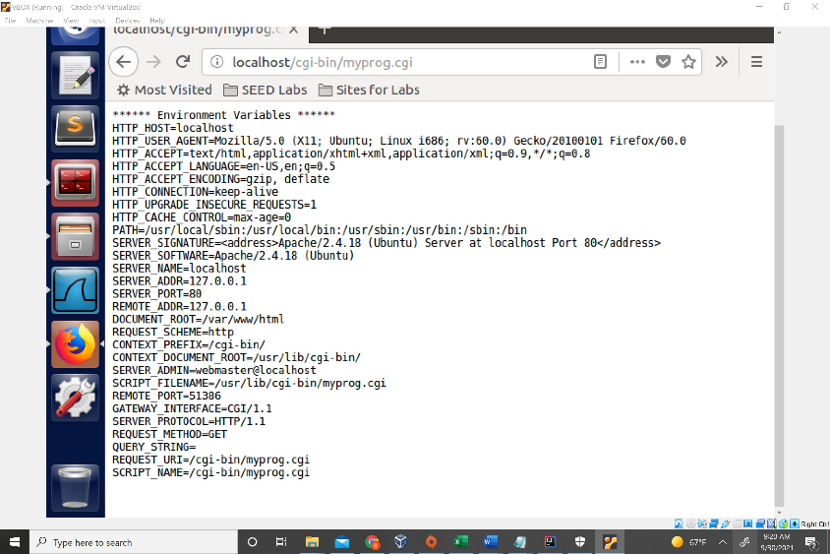

Shellshock Task 4

I created a file called SuperSecretFile which was able to be accessed when I ran the command

curl -A"() { echo hello;}; echo Content_type: text/plain; echo; /bin/cat /superSecretFile" http://localhos t/cgi-bin/myprog.cgi

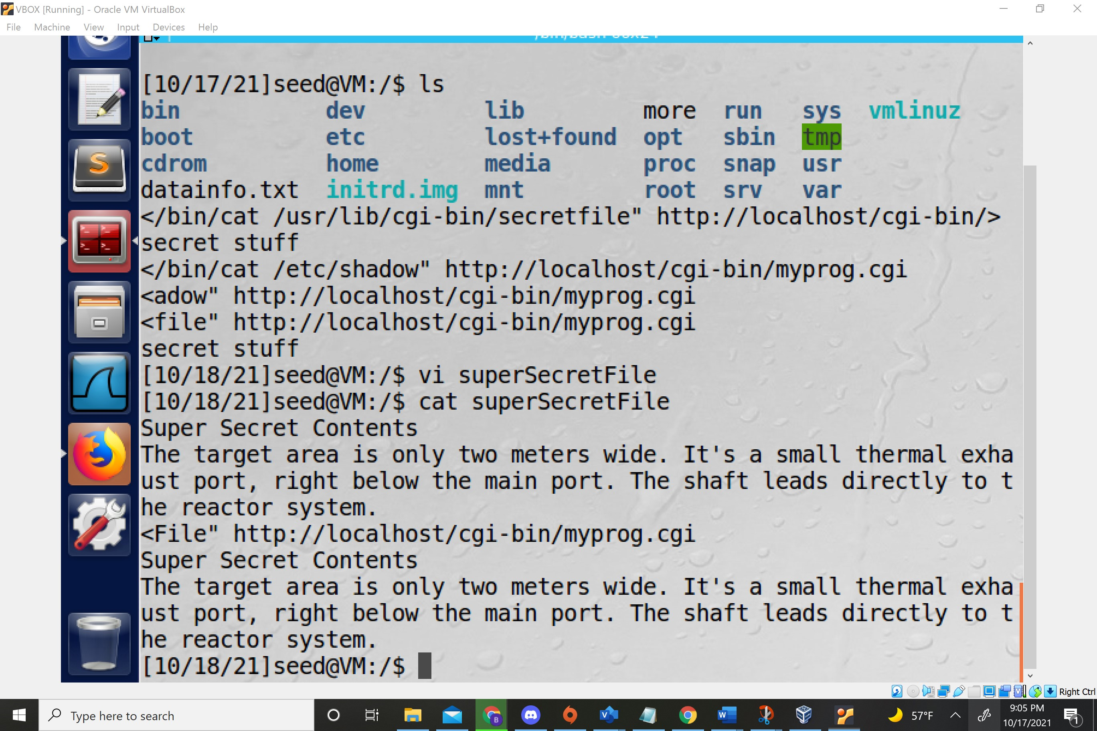

You can’t steal etc/shadow because it is only readable by root and the webserver